GROUPING AND AGGREGATING DATA
- Write a query that shows the total number of items ordered for each product. Use the Sales.SalesOrderDetail table.
SELECT
ProductID,
SUM(OrderQty) AS TotalItemsOrdered
FROM Sales.SalesOrderDetail
GROUP BY ProductID;
Output
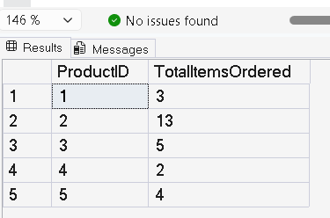

- Write a query using the Production.Product table that lists the count of products in each ProductLine.
SELECT
ProductLine,
COUNT(*) AS ProductCount
FROM Production.Product
GROUP BY ProductLine;

Output
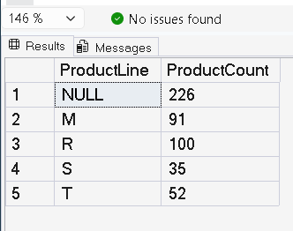

- Write a query that creates a sum of the LineTotal in the Sales.SalesOrderDetail table grouped by the SalesOrderID. Include only those rows where the sum exceeds 1000.
SELECT
SalesOrderID,
SUM(LineTotal) AS TotalAmount
FROM Sales.SalesOrderDetail
GROUP BY SalesOrderID
HAVING SUM(LineTotal) > 1000;

Output
